
ТЕХНИЧЕСКИ УНИВЕРСИТЕТ – ВАРНА
Факултет по изчислителна техника и автоматизация
Катедра „СИТ“
СЕМЕСТРИАЛНА ДОМАШНА РАБОТА
по дисциплината Бази данни
на тема: Автобусни превози
Вариант 3

Изготвил: Теодора Стойчева | Проверил:
Специалност: СИТ
Група: 4-б
Факултетен номер: 22621693
2023

Задание
Да се проектира и реализира база от данни за автобусни превози, която да съхранява следната информация:
- Служител – име, позиция, телефон
- Клиент – име, телефон
- Билет – вид, дестинация, цена
- Резервации – дестинация, дата, час, цена, служител, клиент
Правила:
- Всеки клиент може да закупи или резервира повече от един билет
- По всяка дестинация има много превози
Базата от данни трябва да е нормализирана и да позволява:
1. Въвеждане и корекции на данни
2. Търсене/резервации/закупуване на билети по: дестинация, дата, час.
3. Справки за продадени билети за клиент;
4. Справки за свободни места за дестинация/дата/час;
5. Справки за продажби за период, подредени по дати.

3.Модели
  - Релационен модел

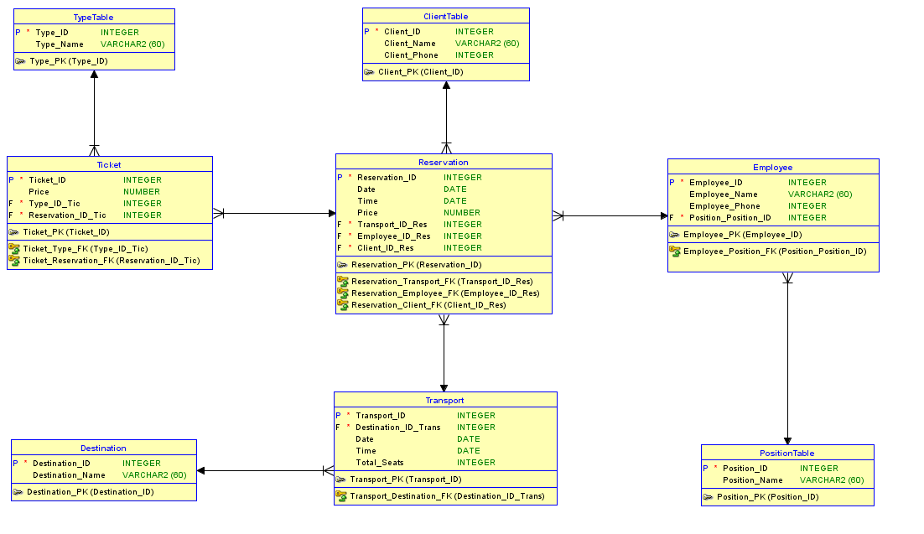

  - Логически модел

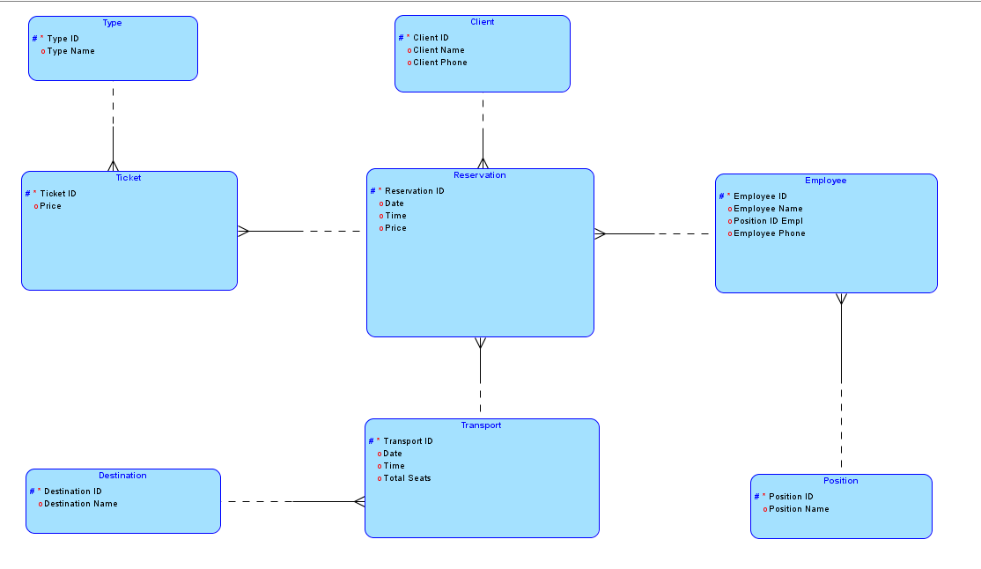
.

4.DDL script (DROP,CREATE,ALTER TABLE)

CLIENTTABLE:

CREATE TABLE clienttable (
client_id INTEGER NOT NULL,
client_name VARCHAR2(60),
client_phone INTEGER
);

ALTER TABLE clienttable ADD CONSTRAINT client_pk PRIMARY KEY ( client_id );

DESTINATION:

CREATE TABLE destination (
destination_id INTEGER NOT NULL,
destination_name VARCHAR2(60)
);

ALTER TABLE destination ADD CONSTRAINT destination_pk PRIMARY KEY ( destination_id );

EMPLOYEE:

CREATE TABLE employee (
employee_id INTEGER NOT NULL,
employee_name VARCHAR2(60),
employee_phone INTEGER,
position_position_id INTEGER NOT NULL
);

ALTER TABLE employee ADD CONSTRAINT employee_pk PRIMARY KEY ( employee_id );

POSITIONTABLE:

CREATE TABLE positiontable (
position_id INTEGER NOT NULL,
position_name VARCHAR2(60)
);

ALTER TABLE positiontable ADD CONSTRAINT position_pk PRIMARY KEY ( position_id );

RESERVATION:

CREATE TABLE reservation (
reservation_id INTEGER NOT NULL,
"Date" DATE,
time DATE,
price NUMBER,
transport_id_res INTEGER NOT NULL,
employee_id_res INTEGER NOT NULL,
client_id_res INTEGER NOT NULL
);

ALTER TABLE reservation ADD CONSTRAINT reservation_pk PRIMARY KEY ( reservation_id );

TICKET:

CREATE TABLE ticket (
ticket_id INTEGER NOT NULL,
price NUMBER,
type_id_tic INTEGER NOT NULL,
reservation_id_tic INTEGER NOT NULL
);
ALTER TABLE ticket ADD CONSTRAINT ticket_pk PRIMARY KEY ( ticket_id );

TRANSPORT:

CREATE TABLE transport (
transport_id INTEGER NOT NULL,
destination_id_trans INTEGER NOT NULL,
"Date" DATE,
time DATE,
total_seats INTEGER
);

ALTER TABLE transport ADD CONSTRAINT transport_pk PRIMARY KEY ( transport_id );

TYPETABLE:

CREATE TABLE typetable (
type_id INTEGER NOT NULL,
type_name VARCHAR2(60)
);

ALTER TABLE typetable ADD CONSTRAINT type_pk PRIMARY KEY ( type_id );
ALTER:
ALTER TABLE employee
ADD CONSTRAINT employee_position_fk FOREIGN KEY ( position_position_id )
REFERENCES positiontable ( position_id );

ALTER TABLE reservation
ADD CONSTRAINT reservation_client_fk FOREIGN KEY ( client_id_res )
REFERENCES clienttable ( client_id );

ALTER TABLE reservation
ADD CONSTRAINT reservation_employee_fk FOREIGN KEY ( employee_id_res )
REFERENCES employee ( employee_id );

ALTER TABLE reservation
ADD CONSTRAINT reservation_transport_fk FOREIGN KEY ( transport_id_res )
REFERENCES transport ( transport_id );

ALTER TABLE ticket
ADD CONSTRAINT ticket_reservation_fk FOREIGN KEY ( reservation_id_tic )
REFERENCES reservation ( reservation_id );

ALTER TABLE ticket
ADD CONSTRAINT ticket_type_fk FOREIGN KEY ( type_id_tic )
REFERENCES typetable ( type_id );

ALTER TABLE transport
ADD CONSTRAINT transport_destination_fk FOREIGN KEY ( destination_id_trans )
REFERENCES destination ( destination_id );

5. DML commands(INSERT,UPDATE,DELETE)

INSERT

INSERT INTO TYPETABLE (TYPE_ID, TYPE_NAME) VALUES (1, 'One Way');
INSERT INTO TYPETABLE (TYPE_ID, TYPE_NAME) VALUES (2, 'Round Trip');

Insert into CLIENTTABLE (CLIENT_ID,CLIENT_NAME,CLIENT_PHONE) values (1,'Anna Ivanova',359001);
Insert into CLIENTTABLE (CLIENT_ID,CLIENT_NAME,CLIENT_PHONE) values (2,'Ivan Ivanov',359002);
Insert into CLIENTTABLE (CLIENT_ID,CLIENT_NAME,CLIENT_PHONE) values (3,'Maria Peneva',359003);
Insert into CLIENTTABLE (CLIENT_ID,CLIENT_NAME,CLIENT_PHONE) values (4,'Georgi Petkov',359004);
Insert into CLIENTTABLE (CLIENT_ID,CLIENT_NAME,CLIENT_PHONE) values (5,'Georgi Georgiev',359005);
Insert into CLIENTTABLE (CLIENT_ID,CLIENT_NAME,CLIENT_PHONE) values (6,'Stanislav Stanislavov',359006);
Insert into CLIENTTABLE (CLIENT_ID,CLIENT_NAME,CLIENT_PHONE) values (7,'Aleksandra Ilieva',359007);
Insert into CLIENTTABLE (CLIENT_ID,CLIENT_NAME,CLIENT_PHONE) values (8,'Martin Ganev',359008);
Insert into CLIENTTABLE (CLIENT_ID,CLIENT_NAME,CLIENT_PHONE) values (9,'Ivanka Stoilova',359009);
Insert into CLIENTTABLE (CLIENT_ID,CLIENT_NAME,CLIENT_PHONE) values (10,'Dimitar Petrov',359010);
Insert into CLIENTTABLE (CLIENT_ID,CLIENT_NAME,CLIENT_PHONE) values (11,'Petar Dimitrov',359011);
Insert into CLIENTTABLE (CLIENT_ID,CLIENT_NAME,CLIENT_PHONE) values (12,'Stoil Ivanov',359012);
Insert into CLIENTTABLE (CLIENT_ID,CLIENT_NAME,CLIENT_PHONE) values (13,'Todor Yordanov',359013);
Insert into CLIENTTABLE (CLIENT_ID,CLIENT_NAME,CLIENT_PHONE) values (14,'Boris Marinov',359014);
Insert into CLIENTTABLE (CLIENT_ID,CLIENT_NAME,CLIENT_PHONE) values (15,'Nikola Velikov',359015);

Insert into DESTINATION (DESTINATION_ID,DESTINATION_NAME) values (1,'Sofia');
Insert into DESTINATION (DESTINATION_ID,DESTINATION_NAME) values (2,'Varna');
Insert into DESTINATION (DESTINATION_ID,DESTINATION_NAME) values (3,'Shumen');
Insert into DESTINATION (DESTINATION_ID,DESTINATION_NAME) values (4,'Burgas');
Insert into DESTINATION (DESTINATION_ID,DESTINATION_NAME) values (5,'Yambol');
Insert into DESTINATION (DESTINATION_ID,DESTINATION_NAME) values (6,'Lovech');
Insert into DESTINATION (DESTINATION_ID,DESTINATION_NAME) values (7,'Silistra');
Insert into DESTINATION (DESTINATION_ID,DESTINATION_NAME) values (8,'Sliven');
Insert into DESTINATION (DESTINATION_ID,DESTINATION_NAME) values (9,'Ruse');
Insert into DESTINATION (DESTINATION_ID,DESTINATION_NAME) values (10,'Popovo');

Insert into EMPLOYEE (EMPLOYEE_ID,EMPLOYEE_NAME,EMPLOYEE_PHONE,POSITION_POSITION_ID) values (1,'Teodor Todorov',359991,1);
Insert into EMPLOYEE (EMPLOYEE_ID,EMPLOYEE_NAME,EMPLOYEE_PHONE,POSITION_POSITION_ID) values (2,'Yordan Penev',359992,1);
Insert into EMPLOYEE (EMPLOYEE_ID,EMPLOYEE_NAME,EMPLOYEE_PHONE,POSITION_POSITION_ID) values (3,'Dimitar Nikolov',359993,1);
Insert into EMPLOYEE (EMPLOYEE_ID,EMPLOYEE_NAME,EMPLOYEE_PHONE,POSITION_POSITION_ID) values (4,'Stoyan Totev',359994,2);
Insert into EMPLOYEE (EMPLOYEE_ID,EMPLOYEE_NAME,EMPLOYEE_PHONE,POSITION_POSITION_ID) values (5,'Georgi Yordanov',359995,2);
Insert into EMPLOYEE (EMPLOYEE_ID,EMPLOYEE_NAME,EMPLOYEE_PHONE,POSITION_POSITION_ID) values (6,'Vasil Stoyanov',359996,2);
Insert into EMPLOYEE (EMPLOYEE_ID,EMPLOYEE_NAME,EMPLOYEE_PHONE,POSITION_POSITION_ID) values (7,'Krasimir Vasilev',359997,3);
Insert into EMPLOYEE (EMPLOYEE_ID,EMPLOYEE_NAME,EMPLOYEE_PHONE,POSITION_POSITION_ID) values (8,'Tanya Krasimirova',359998,4);
Insert into EMPLOYEE (EMPLOYEE_ID,EMPLOYEE_NAME,EMPLOYEE_PHONE,POSITION_POSITION_ID) values (9,'Velichka Teneva',359999,4);
Insert into EMPLOYEE (EMPLOYEE_ID,EMPLOYEE_NAME,EMPLOYEE_PHONE,POSITION_POSITION_ID) values (10,'Presiyan Velikov',359910,4);
Insert into EMPLOYEE (EMPLOYEE_ID,EMPLOYEE_NAME,EMPLOYEE_PHONE,POSITION_POSITION_ID) values (11,'Maria Getseva',359911,5);
Insert into EMPLOYEE (EMPLOYEE_ID,EMPLOYEE_NAME,EMPLOYEE_PHONE,POSITION_POSITION_ID) values (12,'Nikolina Marinova',359912,5);
Insert into EMPLOYEE (EMPLOYEE_ID,EMPLOYEE_NAME,EMPLOYEE_PHONE,POSITION_POSITION_ID) values (13,'Elisaveta Dimcheva',359913,6);
Insert into EMPLOYEE (EMPLOYEE_ID,EMPLOYEE_NAME,EMPLOYEE_PHONE,POSITION_POSITION_ID) values (14,'Kristiyan Dragomirov',359914,7);
Insert into EMPLOYEE (EMPLOYEE_ID,EMPLOYEE_NAME,EMPLOYEE_PHONE,POSITION_POSITION_ID) values (15,'Ekaterina Boyanova',359915,7);
Insert into EMPLOYEE (EMPLOYEE_ID,EMPLOYEE_NAME,EMPLOYEE_PHONE,POSITION_POSITION_ID) values (16,'Boyan Darinov',359916,8);
Insert into EMPLOYEE (EMPLOYEE_ID,EMPLOYEE_NAME,EMPLOYEE_PHONE,POSITION_POSITION_ID) values (17,'Daria Radichkova',359917,9);
Insert into EMPLOYEE (EMPLOYEE_ID,EMPLOYEE_NAME,EMPLOYEE_PHONE,POSITION_POSITION_ID) values (18,'Raya Dobromirova',359918,10);
Insert into EMPLOYEE (EMPLOYEE_ID,EMPLOYEE_NAME,EMPLOYEE_PHONE,POSITION_POSITION_ID) values (19,'Dobromir Hristov',359919,10);
Insert into EMPLOYEE (EMPLOYEE_ID,EMPLOYEE_NAME,EMPLOYEE_PHONE,POSITION_POSITION_ID) values (20,'Hristo Kozarev',359920,10);

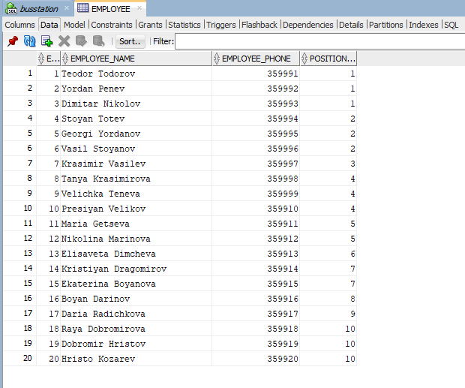
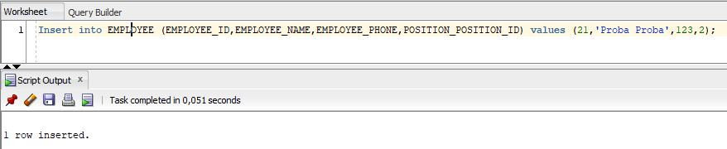
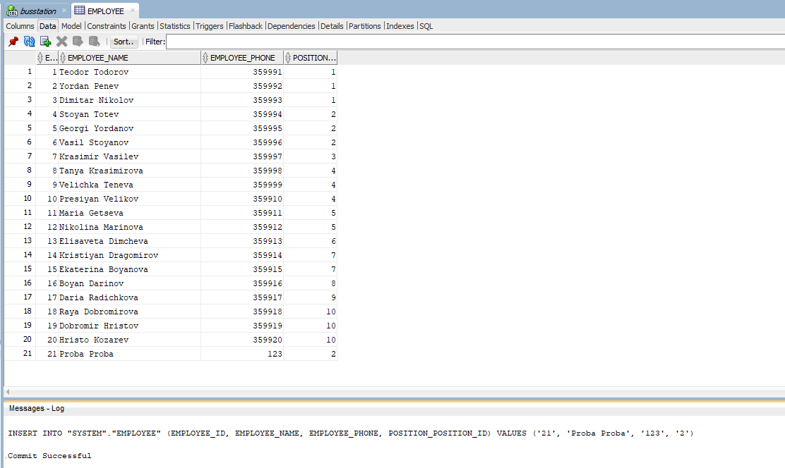

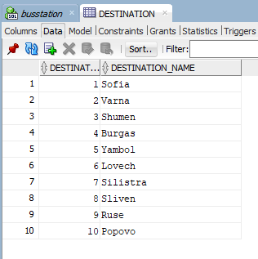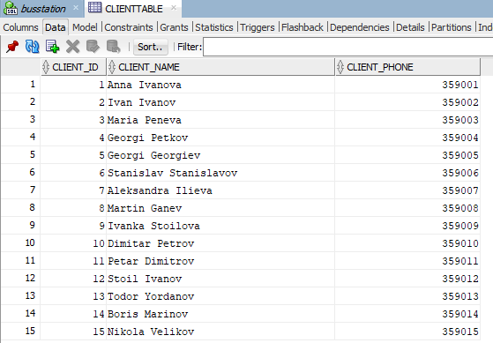

UPDATE
UPDATE CLIENTTABLE
SET CLIENT_NAME='Anna Ivanova' CLIENT_PHONE='359001'
WHERE CLIENT_ID=1;

UPDATE CLIENTTABLE
SET CLIENT_NAME='&CLIENT_NAME',CLIENT_PHONE='&CLIENT_PHONE'
WHERE CLIENT_ID=&CLIENT_ID;

UPDATE EMPLOYEE
SET EMPLOYEE_NAME'&EMPLOYEE_NAME'
WHERE EMPLOYEE_ID=&EMPLOYEE_ID;

UPDATE EMPLOYEE
SET EMPLOYEE_PHONE='&EMPLOYEE_PHONE'
WHERE EMPLPYEE_ID=1

UPDATE TICKET
SET TYPE_ID_TIC='&TYPE_ID_TIC'
WHERE TICKET_ID=5;

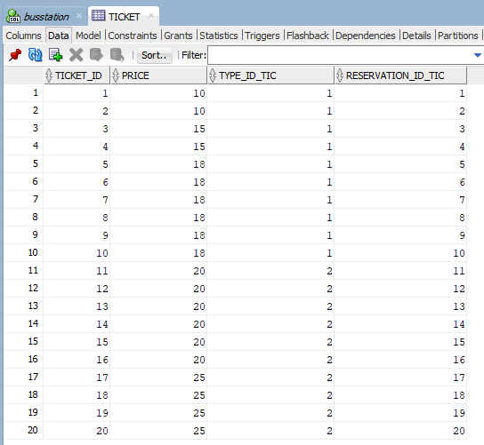
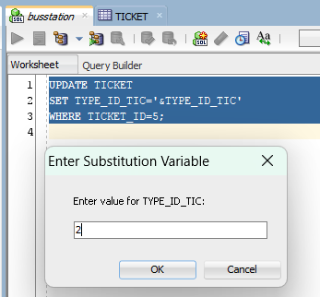
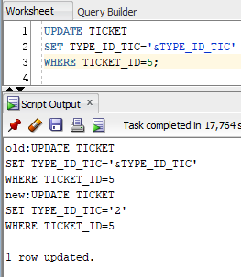
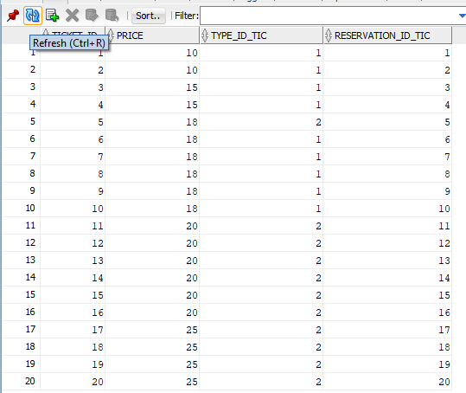

DELETE

DELETE FROM DESTINATION
WHERE DESTINATION_ID=&DESTINATION_ID;

DELETE FROM TICKET
WHERE TICKET_ID=7;

DELETE FROM CLIENT
WHERE CLIENT_ID=9;

DELETE FROM RESERVATION
WHERE TRANSPORT_ID_RES=&TRANSPORT_ID_RES;

DELETE FROM POSITIONTABLE
WHERE POSITION_ID=3;

DELETE FROM TRANSPORT
WHERE DESTINATION_ID_TRANS=3;

DELETE FROM EMPLOYEE
WHERE EMPLOYEE_ID=&EMPLOYEE_ID;

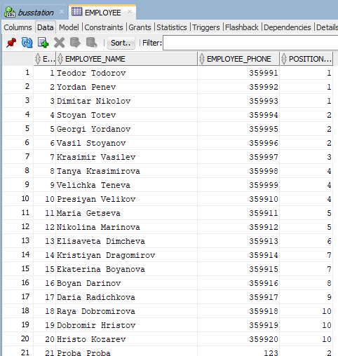
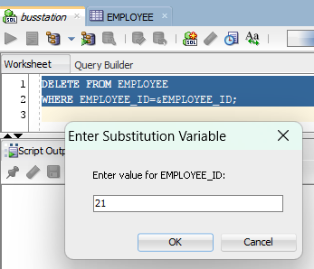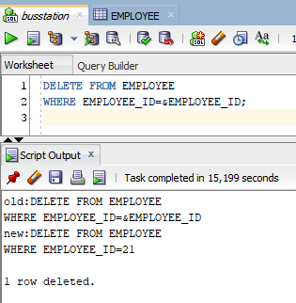
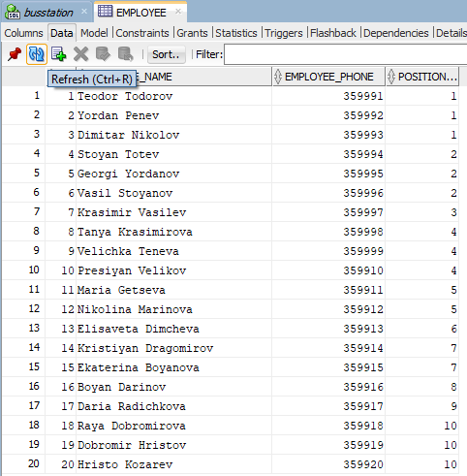

SELECT Търсене/резервиране/закупуване на билети по дестинация, дата, час
  - Дестинация:

SELECT

SELECT

r."Date" as reservation_date,

r.time as reservation_time,

t.type_name as ticket_type,

c.client_name as client_name,

tr.total_seats as total_seats

FROM ticket tic

JOIN reservation r ON tic.reservation_id_tic = r.reservation_id

JOIN typetable t ON tic.type_id_tic = t.type_id

JOIN clienttable c ON r.client_id_res = c.client_id

JOIN transport tr ON r.transport_id_res = tr.transport_id

JOIN destination d ON tr.destination_id_trans = d.destination_id

WHERE destination_name='&Destination'; 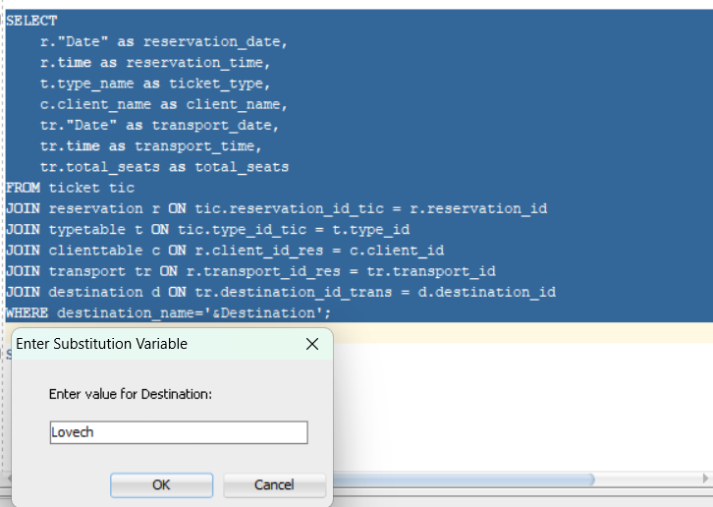

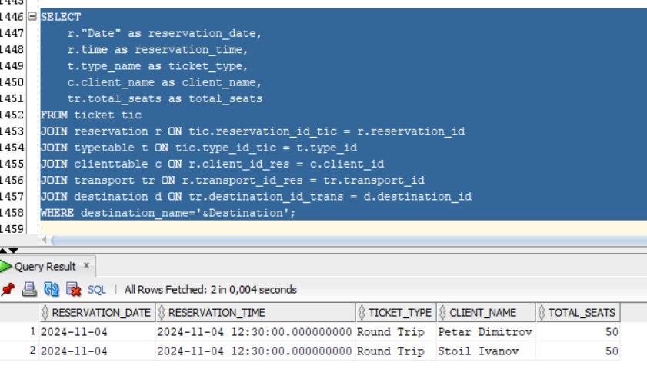
  - Дата:

SELECT

t.type_name as ticket_type,

c.client_name as client_name,

d.destination_name as destination,

tr."Date" as transport_date,

tr.time as transport_time,

tr.total_seats as total_seats

FROM ticket tic

JOIN reservation r ON tic.reservation_id_tic = r.reservation_id

JOIN typetable t ON tic.type_id_tic = t.type_id

JOIN clienttable c ON r.client_id_res = c.client_id

JOIN transport tr ON r.transport_id_res = tr.transport_id

JOIN destination d ON tr.destination_id_trans = d.destination_id

WHERE r."Date" = TO_DATE('&Date', 'DD-MM-YYYY');

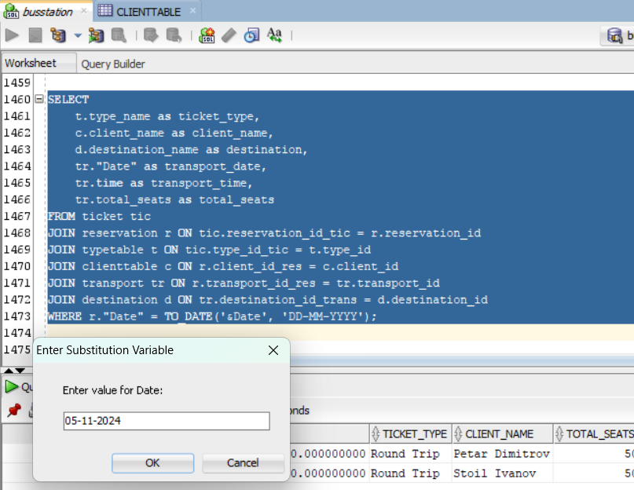

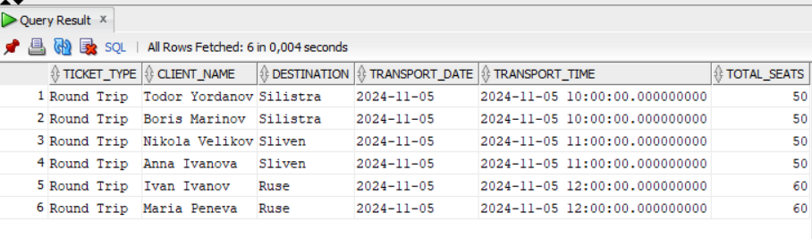

  - Час:

SELECT

t.type_name as ticket_type,

c.client_name as client_name,

d.destination_name as destination,

tr."Date" as transport_date,

tr.time as transport_time,

tr.total_seats as total_seats

FROM ticket tic

JOIN reservation r ON tic.reservation_id_tic = r.reservation_id

JOIN typetable t ON tic.type_id_tic = t.type_id

JOIN clienttable c ON r.client_id_res = c.client_id

JOIN transport tr ON r.transport_id_res = tr.transport_id

JOIN destination d ON tr.destination_id_trans = d.destination_id

WHERE TO_CHAR(tr.time, 'HH24:MI:SS.FF6') = '&Time';);

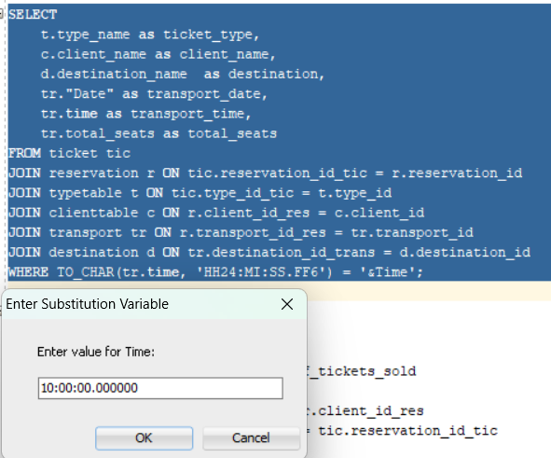

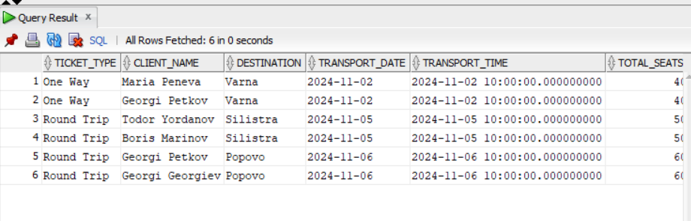

Справки за:

Продадени билети на клиент:

SELECT

c.client_name AS client_name,

c.client_phone AS client_phone,

COUNT(tic.ticket_id) AS number_of_tickets_sold

FROM clienttable c

JOIN reservation r ON c.client_id = r.client_id_res

JOIN ticket tic ON r.reservation_id = tic.reservation_id_tic

GROUP BY c.client_name, c.client_phone;

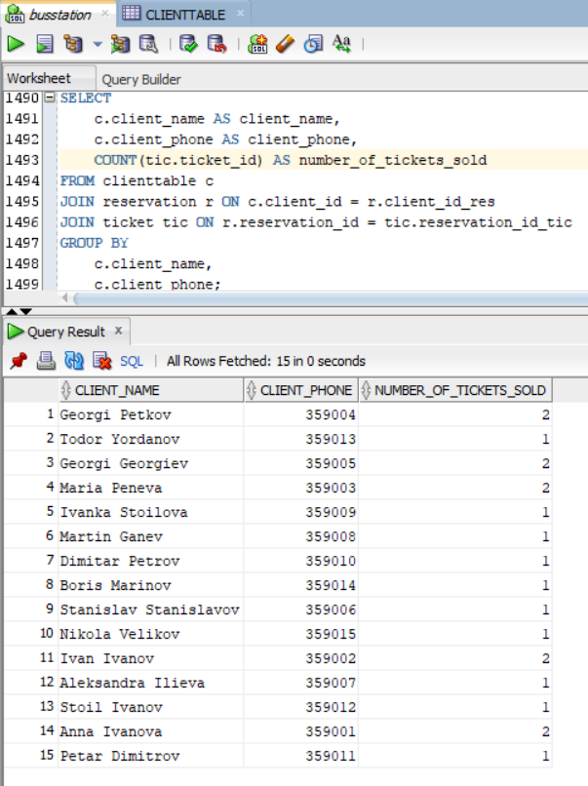

Свободни места за дестинация, дата, час

SELECT

d.destination_name AS destination_name,

tr."Date" AS transport_date,

tr.time AS transport_time,

tr.total_seats - COUNT(tic.ticket_id) AS number_of_free_seats

FROM transport tr

JOIN destination d ON tr.destination_id_trans = d.destination_id

LEFT JOIN reservation r ON r.transport_id_res = tr.transport_id

LEFT JOIN ticket tic ON r.reservation_id = tic.reservation_id_tic

GROUP BY

d.destination_name,

tr."Date",

tr.time,

tr.total_seats;

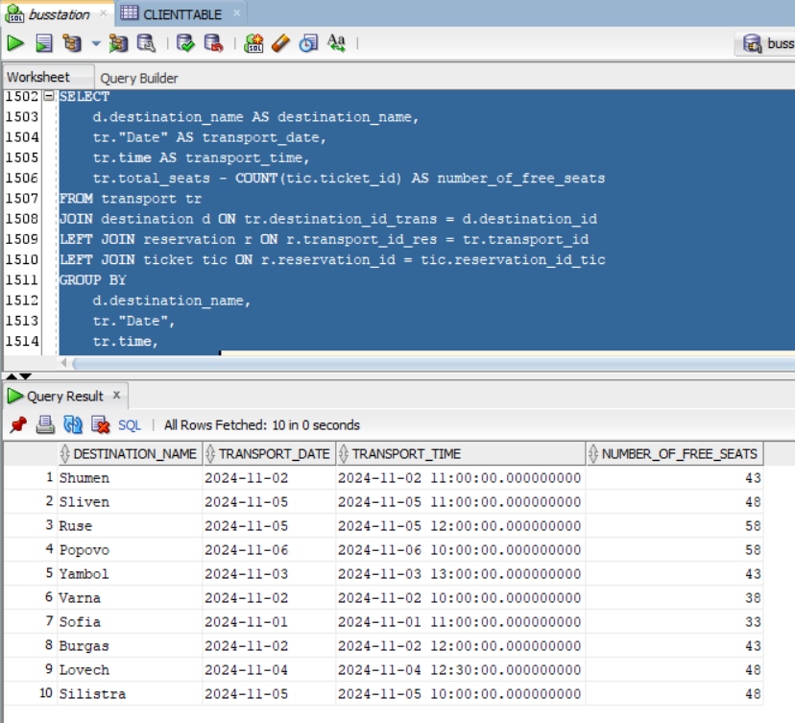

Продажби за период, подредени по дати

SELECT

tr."Date" AS transport_date,

tr.time AS transport_time,

d.destination_name AS destination,

c.client_name AS client_name,

t.type_name AS ticket_type

FROM ticket tic

JOIN reservation r ON tic.reservation_id_tic = r.reservation_id

JOIN transport tr ON r.transport_id_res = tr.transport_id

JOIN destination d ON tr.destination_id_trans = d.destination_id

JOIN clienttable c ON r.client_id_res = c.client_id

JOIN typetable t ON tic.type_id_tic = t.type_id

WHERE tr."Date" BETWEEN TO_DATE('&StartDate', 'DD-MM-YYYY') AND TO_DATE('&EndDate', 'DD-MM-YYYY')

ORDER BY tr."Date" ASC;

